### Experiment – No-7

|  |  |  |
| --- | --- | --- |
| Objective: Program to find the factorial of a number. | | |
| Scheduled Date | Compiled Date | Submission Date |
| 09-Jan-2021 | 09-Jan-2021 | 10-Jan-2021 |

### Program : A program to find the factorial of a number.

### Algorithm

### Step 1- Start

### Step 2- Declare variable num , i , fact

### Step 3- Read variable num.

### Step 4- Apply for loop:

### for(i=num;i>=1;i--)

### Step 5- Given:

### Fact=fact*i

### Step 6- Print

### Step 7- Stop.

**Program**

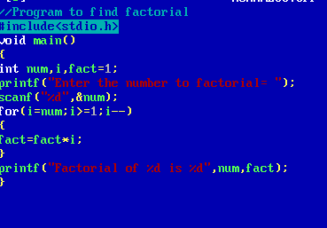

### Output Screen

### C:\Users\WIN10\Pictures\ss8.png